
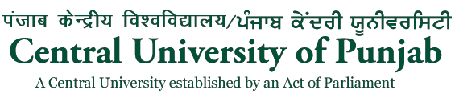

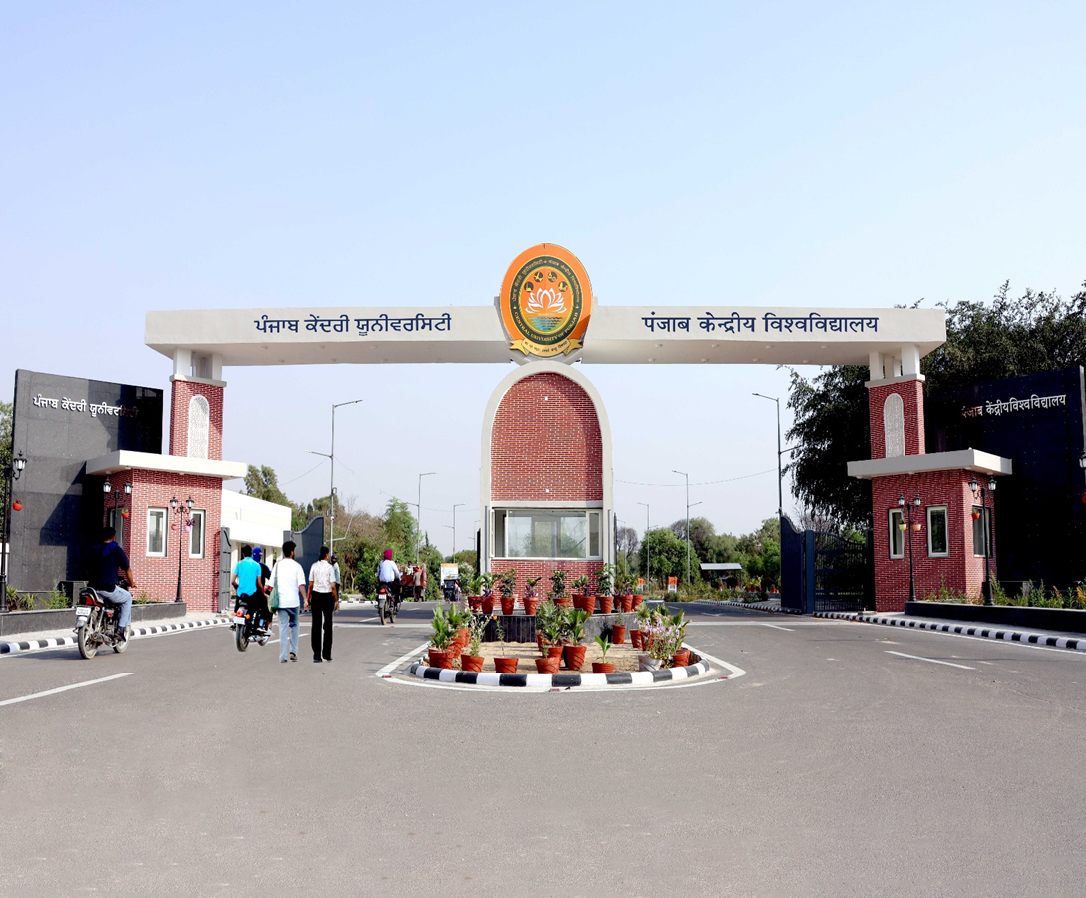
NAAC ACCREDITED ‘A+’ GRADE UNIVERSITY & 77th RANK IN NIRF-2025

PROSPECTUS

Admissions to

Ph.D. Programmes
(Regular & Part-Time Ph.D.)

Academic Session : 2026-27
(July - 2026 Intake)
Certified for Quality Management System ISO (9001:2015) & Environment Management System (ISO 14001:2015)

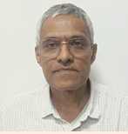
FROM THE ACTING VICE-CHANCELLOR’S DESK

Prof. Ramakrishna Wusirika
Dear Students,

Welcome to the Central University of Punjab!

The Central University of Punjab has been established through an Act of Parliament: "The Central Universities Act, 2009" by Govt. of India. The territorial jurisdiction of Central University of Punjab is whole of the State of Punjab.

The University has an energy-efficient green campus with state-of-the-art infrastructure coupled with modern research and sports facilities in an area of over 500 acres at village Ghudda, District Bathinda, Punjab.

The Central University of Punjab has been ranked in the top 100 for the last seven consecutive years in 2019, 2020, 2021, 2022, 2023, 2024 and 2025 by NIRF (University catagory). At a young age of 17 years of establishment, the University has proved itself with NAAC 'A+' Grade.

The University is one of the fast growing Higher Educational Institutions in the Country and committed to Sustainable Development Goals. The University envisions to transform the minds to serve the humanity through skill and innovation driven teaching and research; values and community outreach. The University offers a wide range of instructional and research facilities across integrated and cross-disciplinary studies, to create an ignited workforce responsive to regional, national and global needs in tune with the requirements of academics, industry, business and administration and to address the issues and concerns of the community.

We aim to constantly motivate young minds to experience the excitement and adventure that education offers and inculcate amongst students and faculty, the healthy habits of self-reliance rather than dependence. We strive on holistic development of personality to face challenges of life while ensuring welfare of all life forms and life support systems; activate creative instincts, motivate independent thinking; develop questioning minds and to nurture a sense of integrity, ethics, uncompromising honesty, democratic values, respect for human rights and deep concern for the disadvantaged section of the society.

We, at Central University of Punjab understand that success is based on high quality courses, good facilities, friendly ambience and dedicated academic staff. Here, we practise what we teach and our students can count on full support of faculty and administration.

Our strength lies in dedicated and meritorious faculty, quality infrastructural research facilities and visibility in research output. The innovative courses so designed also save precious time, money and energy of the students while they remain focused to the field of their choice.

With a much-focussed approach, the university is undoubtedly poised to write a new chapter on the academic horizon of India.

I appreciate you considering the Central University of Punjab as your next academic institution and look forward to welcome you!

With best wishes,
( Prof. Ramakrishna Wusirika)

About Central University of Punjab

The Central University of Punjab was established in 2009 by an Act of Parliament. The University ranked 77th by the National Institutional Ranking Framework (NIRF), 2025. Further, in the second accreditation cycle, the University has been accredited with "A+" grade by the National Assessment and Accreditation Council (NAAC). CU Punjab is ranked in the band of 601–800 in the Times Higher Education (THE) World University Rankings 2026. The university is ISO- 9001: 2015 (Quality Management System in Education) & ISO 14001:2015 (Environment Management System) certified. The University has a mission of providing wide range of instructional and research facilities across integrated and cross-disciplines, to promote innovation in teaching, learning and research, and cross-pollinate new ideas, new technologies and new world-views. It aims to create an ignited workforce responsive to regional, national and global needs in tune with the requirements of academic, industry and business. |  |  |  |  | 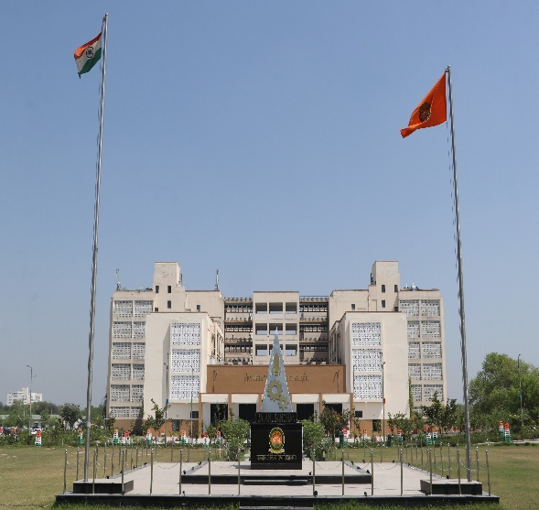
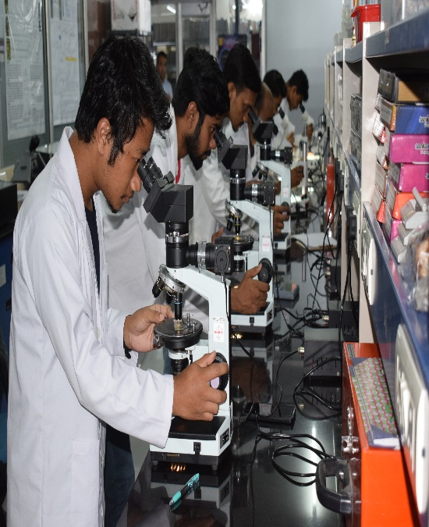 | The University started in a Camp Office provided by the State administration in March, 2009. Presently, the University is functioning from its 500-acre campus situated at village Ghudda in Bathinda District of Punjab. The University is Anchor Institution for online courseware development for Environment Sciences for e-PG Pathshala platforms. The University has also developed MOOCs for SWAYAM. The University has a state-of-the-art Central Instrumentation Laboratory, Computer Centre and the University Library to provide high-end facilities to its faculty and students. Air-conditioned lecture rooms, well-equipped science laboratories, a 125-seater seminar hall and a 250-seater air-conditioned auditorium support the academic activities.
The 500 acres University campus is designed to be environment friendly and energy efficient and is conforming to GRIHA-IV norms. The University Master Plan has provisionally been certified with 5-star rating by GRIHA and TERI. The University secured first position in 14th National Youth Parliament (in group level) competition. Two teachers of the University had been part of “36th Indian Scientific Expedition to Antarctica” and worked at Bharti & Maitri research stations. Nine Departments of the University have been supported with DST-FIST grants. The university secured DST-PURSE grant sponsored from iTBI NIDHI and EYUVA Center sponsored by DBT. Recently, ANRF PAIR project was funded with JNU as Hub and CU Punjab as a Spoke providing new opportunities for research for students. |  |  | 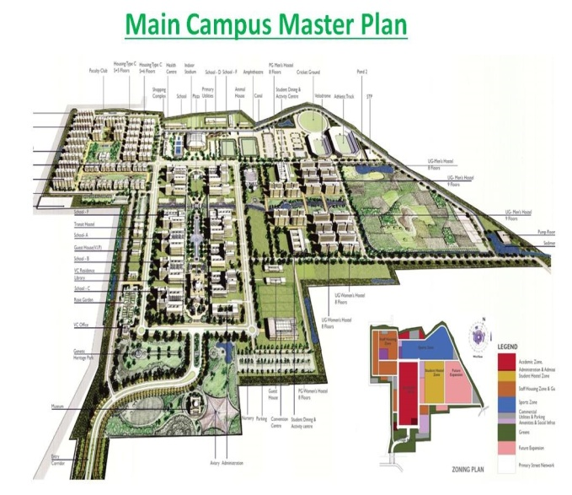
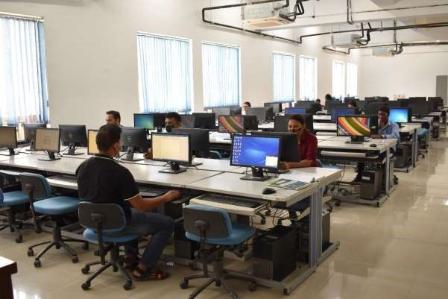 |  | Currently, the University has 36 Departments, 02 Centre under 11 Schools of Studies in the areas ranging from Sciences, Technology, Humanities, Law and Social Sciences. The University has implemented the National Education Policy, 2020 from the session 2021-22. The University offers Bachelor, Masters and Ph.D. Programmes. It also offers Short-Term Courses for skill development. It is a validation of University's growing credibility among the students that during the year 2025-26. The University has attained 114 h-index (Scopus) and 104 h-index (Web of Science) and 108658 citations (Scopus) and 81479 citations (Web of Science) and 4160 Papers (Scopus) and 3360 papers (Web of Science). For Ph.D. Programmes, 524 applications were received for 222 seats.
Besides celebrating international and national commemorative days, students are encouraged to organize and participate in annual sports and cultural events throughout the year. To cater to the financial needs of the students, the University provides scholarships and interest-free loans out of the Students Welfare Fund and has also implemented Earn-While-You-Learn Scheme. |  |  |  | 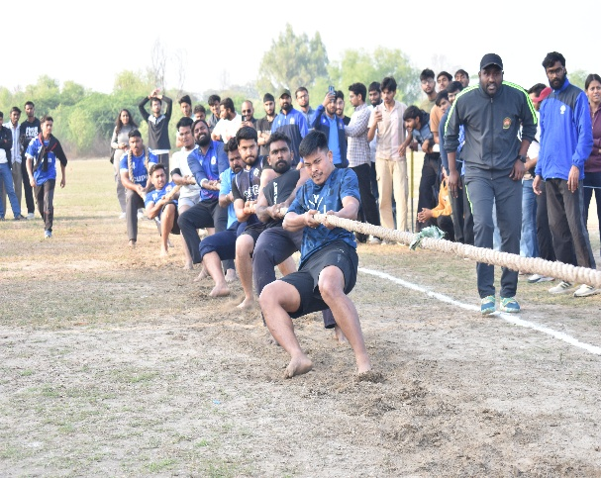
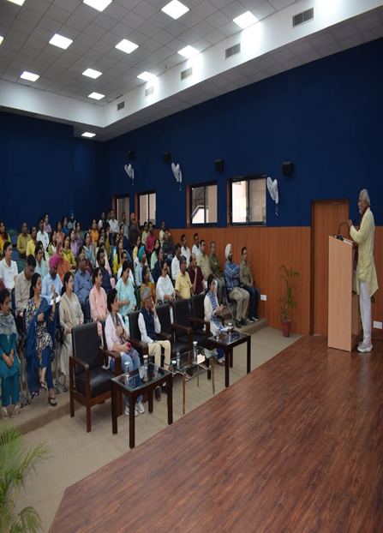 |  | The University is multi-cultural and multi-lingual as it has students from 28 States, 07 UTs and International students from Afghanistan, Bangladesh, Burundi, Egypt, Ethiopia, Ghana, Indonesia, Iran, Kenya, Lesotho, South Africa, Swaziland, Syria, Tanzania, Uganda, Yemen, faculty members and non-teaching staff from most of the States. The University takes pride in its exceptionally qualified and committed faculty as all are NET qualified and have doctoral degree. It is remarkable that majority of the faculty have the experience of working in international laboratories and prestigious foreign Universities. The university faculty includes DST INSPIRE, Ramanujan Fellow, Ramalingaswami Fellow, UGC-FRP and DAAD fellow etc. Faculties are also members of prestigious Royal Society of Chemistry, Linnean Society of London and INYAS-INSA. The University has good Research Projects: Faculty Ratio. So far, over 229 Extramural Research Grants from external agencies and 160 research Seed Money grants (University funded) have been sanctioned to the faculty.  With a focused approach, the University is undoubtedly poised to write a new chapter on the academic horizon of India.

VISION

The University envisions to continuously transform the minds to serve humanity through skills, innovation and sustainability driven teaching and research; values and community outreach.

MISSION

- Provide a wide range of instructional and research ecosystem for inter-, multi- and trans-disciplinary approaches to impart holistic learning,

- Promote skills and innovation in teaching-learning and research, and crosspollinate new ideas, technologies and new world-views,

- Create an ignited and inclusive workforce responsive to regional, national and global needs in tune with the requirements of academia, industry and society,

- Envisage to respond dynamically and creatively towards shifting paradigms in education to meet the changing needs of the evolving society.

ACADEMIC PROGRAMMES AND ELIGIBILITY
The following Departments of the Central University of Punjab are offering admission to Ph.D. Programmes commencing from Academic session 2026-27 (July-26 Intake):
S. No. | Programmes |  |  | Eligibility Criteria |  | Area of Specialization | No. of  Seats
SCHOOL OF BASIC SCIENCES
DEPARTMENT OF CHEMISTRY
1 | Chemistry |  |  | Master’s degree in Chemistry (Inorganic/ Organic/ Physical/ Analytical/ Bio-inorganic/ Bio-Physical/ Medicinal/ Applied/ Pharmaceutical) and Biochemistry, Biotechnology, Biophysics with minimum of 55% marks {50% for SC/ ST/ OBC (NCL)/ PWD} from a recognized Indian or foreign University. |  | Organic and Medicinal Chemistry, Green Chemistry, Organic Synthesis, Catalysis, Neurological disorders, Bio-inorganic and Biophysical Chemistry, Physical and Nanomaterial | 16
DEPARTMENT OF COMPUTATIONAL SCIENCES
2 | Theoretical and Computational Chemistry |  |  | Master’s degree in Chemistry or any other relevant areas with minimum of 55% marks {50% for SC/ST/OBC(NCL)/PWD} from a recognized Indian or foreign University. |  | Molecular Reaction Dynamics, Molecular Mmodelling and Drug Design | 03
3 | Computational Physics |  |  | Master’s degree in Physics or any other relevant areas with minimum of 55% marks {50% for SC/ST/OBC(NCL)/PWD} from a recognized Indian or foreign University. |  | Condensed Matter Physics | 03
DEPARTMENT OF MATHEMATICS AND STATISTICS
4 | Mathematics |  |  | Master’s degree in Mathematics with minimum of 55% marks {50% for SC/ST/OBC(NCL)/PWD} from a recognized Indian or foreign University. |  | Differential Geometry, Topology, Operational Research | 07
5 | Statistics |  |  | Master’s degree in Statistics with minimum of 55% marks {50% for SC/ST/OBC(NCL)/PWD} from a recognized Indian or foreign University. |  | Statistics | 03
DEPARTMENT OF PHYSICS
6 | Physics |  |  | Master’s degree in Physics/Applied Physics with minimum of 55% marks {50% for SC/ST/OBC (NCL)/PWD} from a recognized Indian or foreign University. |  | Advanced Laser Spectroscopy, Electromagnetic Metamaterials, Acuostic Metamaterials, Quantum Comutation, Machine learning in Energy Conversion and Storage, Electrical and Magnetotransport Studies of Quantum Materials , Plasma Diagnosis, Ion Beam Diagnosis, Supercapacitor, Battery, Solar Cells, Low Energy Effects on Thin Films, Hard Condensed Matter and Quantum Physics, Energy Materials and Applied Physics, Renewable Energy Materials (Experimental & Theoretical) | 24
DEPARTMENT OF BOTANY
7 | Botany |  |  | Master’s degree in Botany, Plant Sciences and allied subjects in Life Sciences with minimum of 55% marks {50% for SC/ST/OBC(NCL)/PWD} from a recognized Indian or foreign University. |  | Plant Biotechnology, Plant Tissue Culture, Stress Physiology and Agal Biology | 03
DEPARTMENT OF ZOOLOGY
8 | Zoology |  |  | Master’s degree in any branch of Life Sciences/ Veterinary Sciences with minimum of 55% marks {50% for SC/ST/OBC (NCL) /PWD} from a recognized Indian or foreign University. |  | Neurobiology/Medical Genetics / Soil Nematode / Diversity and Ecology / molecular characterization, specialization in Neurobiology / Bioinformatics / Reproductive Biology and Molecular Biology | 05
DEPARTMENT OF BIOCHEMISTRY
9 | Biochemistry |  |  | Master’s degree in Life Sciences or related area with minimum of 55% marks {50% for SC/ ST/ OBC (NCL)/ PWD} from a recognized Indian or foreign University. |  | Thrombus Biology, Nanobiotechnology, Nano-informatics, Applied Plant and Environmental Biochemistry, Immunobiology of Diseases | 04
DEPARTMENT OF MICROBIOLOGY
10 | Microbiology |  |  | Master’s degree in Life Sciences or allied subjects with minimum of 55% marks {50% for SC/ST/OBC (NCL)/PWD} from a recognized Indian or foreign University. |  | Microbiology | 12
DEPARTMENT OF APPLIED AGRICULTURE
11 | Agribusiness |  |  | MBA (Agribusiness)/ Master's Degree in Agricultural Marketing with minimum of 55% marks {50% for SC/ST/OBC (NCL)/PWD} from a recognized Indian or foreign University. |  | Agribusiness | 04
12 | Food Science & Technology |  |  | Master’s Degree in food science and allied fields with minimum of 55% marks {50% for SC/ST/OBC (NCL)/PWD} from a recognized Indian or foreign University. |  | Food Science and Technology | 04
DEPARTMENT OF BIOTECHNOLOGY & BIOINFORMATICS
13 | Bioinformatics |  |  | Master’s degree in Bioinformatics/Life Sciences/Biotechnology/Physics/Chemistry or any other relevant areas with minimum of 55% marks {50% for SC/ST/OBC(NCL)/PWD} from a recognized Indian or foreign University. |  | Structural Bioinformatics, AI/ML in Biology, Molecular Modelling, Genomics, Transcriptomics | 04
14 | Biotechnology |  |  | Master’s degree in Life Sciences or related area with minimum of 55% marks {50% for SC/ ST/ OBC (NCL)/ PWD} from a recognized Indian or foreign University. |  | Biotechnology | 03
SCHOOL OF EDUCATION
DEPARTMENT OF PHYSICAL EDUCATION
15 | Physical Education |  |  | Master’s degree in Physical Education or Physical Education & Sports or Sports Sciences with minimum of 55% marks {50% for SC/ST/OBC (NCL)/PWD} from a recognized Indian or foreign University. |  | Physical Education | 07
DEPARTMENT OF EDUCATION
16 | Education |  |  | Master’s degree in Education with minimum of 55% marks {50% for SC/ST/OBC(NCL)/PWD} from a recognized Indian or foreign University. |  | Educational technology & ICT in Education, Inclusive Education, Advanced Educational Psychology, Educational Management & Leadership | 07
SCHOOL OF ENGINEERING AND TECHNOLOGY
DEPARTMENT OF COMPUTER SCIENCE AND TECHNOLOGY
17 | Computer Science & Technology |  |  | Master of Engineering degree in Computer Engineering, Computer Science & Technology, Information Technology or equivalent from a recognized Indian or foreign University with minimum 55% marks or 6 CGPA (50% Marks or 5.5 CGPA for SC/ST/OBC (NCL)/PWD).  Or  M.Sc. (Computer Science/Information Technology) or an equivalent degree in an appropriate area from a recognized Indian or foreign University with minimum 75% marks (70% Marks for SC/ST/OBC (NCL)/PWD).  Or  MCA from recognized Indian or foreign University or equivalent with minimum 75% marks (70% Marks for SC/ST/OBC (NCL)/PWD). |  | Large Language Model, Generative AI,  Natural Language Processing, Computer Vision, Cyber Security, Quantum Computing, Machine Learning, Deep Learning, Computer Networks, Health Informatics, Digital Health | 12
DEPARTMENT OF AI & ML
18 | AI and Machine Learning |  |  | Master of Engineering degree in Computer Engineering, Computer Science & Technology, Information Technology or equivalent from a recognized Indian or foreign University with minimum 55% marks or 6 CGPA (50% Marks or 5.5 CGPA for SC/ST/OBC (NCL)/PWD).  Or  M.Sc. (Computer Science/Information Technology) or an equivalent degree in an appropriate area from a recognized Indian or foreign University with minimum 75% marks (70% Marks for SC/ST/OBC (NCL)/PWD).  Or  MCA from recognized Indian or foreign University or equivalent with minimum 75% marks (70% Marks for SC/ST/OBC (NCL)/PWD). |  | Blockchain Technology, Big Data Analytics, Data Science, AI & ML. Quantum Machine Learning | 04
SCHOOL OF ENVIRONMENT AND EARTH SCIENCES
DEPARTMENT OF ENVIRONMENTAL SCIENCE AND TECHNOLOGY
19 | Environmental Sciences |  |  | Master’s degree in Environmental Sciences / Environmental Engineering / Environment Science & Technology / Biotechnology / Botany / Chemistry / Civil Engineering with specialization in Environment / Energy & Environment with 55% marks {50% for SC/ST/OBC (NCL)/PWD} from a recognized Indian or foreign University. |  | Environmental Pollution, Wastewater treatment, EIA, Climate change, Sustainability, Cleaner production |  | 08
DEPARTMENT OF GEOLOGY
20 | Geology |  |  | Master’s degree in Geology/ Earth Science/ Geological Science/ Applied Geology/ Marine Geology/ Environmental Science*/ Physics*/ Chemistry*/ Allied Subjects*” with 55% marks {50% for SC/ST/OBC (NCL)/PWD} from a recognized Indian or foreign University.  *Students from such background should have keen interest to take up research in the field of Earth Sciences and it will be evaluated case wise. |  | Geochemistry, Hydrogeology, Paleontology, Ore geology, Paleomagnetism, Metamorphic petrology, Igneous petrology |  | 09
DEPARTMENT OF GEOGRAPHY
21 | Geography |  |  | Master’s degree in Geography/Urban Planning/Geo- informatics/Population studies with 55% marks {50% for SC/ST/OBC (NCL)/PWD} from a recognized Indian or foreign University. |  | Geography, geoinformatucs,, Natural Resource Management, Disater management |  | 04
SCHOOL OF HEALTH SCIENCES
DEPARTMENT OF HUMAN GENETICS AND MOLECULAR MEDICINE
22 | Human Genetics |  |  | Master’s degree in any branch of Life Sciences with minimum of 55% marks {50% for SC/ ST/ OBC (NCL)/ PWD} from a recognized Indian or  foreign University. |  | Human Genetics |  | 05
23 | Molecular Medicine |  |  | Master’s degree in any branch of Life Sciences with minimum of 55% marks {50% for SC/ ST/ OBC (NCL)/ PWD} from a recognized Indian or foreign University. |  | Molecular Medicine |  | 05
DEPARTMENT OF COMMUNITY MEDICINE AND HEALTH
24 | Community Medicine & Health |  |  | Master’s degree in any branch of Life Sciences with minimum of 55% marks {50% for SC/ ST/ OBC (NCL)/ PWD} from a recognized Indian or  foreign University. |  |  |  | 05
DEPARTMENT OF PHARMACEUTICAL SCIENCES AND NATURAL PRODUCTS
25 | Medicinal Chemistry |  |  | Master’s degree in M.Pharm./ M.S.(Pharm.)/ M.Sc. or equivalent in Medicinal Chemistry/ Pharmaceutical Chemistry/ Chemistry with minimum of 55% marks {50% for SC/ ST/ OBC (NCL)/ PWD} from a recognized Indian or foreign University. |  | Medicinal Chemistry |  | 10
26 | Pharmaceutical Sciences |  |  |  |  | Pharmaceutical Sciences/ Pharmacognosy /Pharmaceutical Chemistry/ Medicinal Chemistry |  | 10
DEPARTMENT OF PHARMACOLOGY
27 | Pharmacology |  |  | [B. Pharm/B.Sc. in Life Sciences (4 year undergraduate course) and Master’s degree in M. Pharm/ M.S. (Pharm) or equivalent in Pharmaceutical Sciences / Pharmacology with minimum of 60% marks {55% for SC/ ST/ OBC (NCL)/ PWD} from a recognized Indian or foreign University]. |  | Pharmacology |  | 02
SCHOOL OF INFORMATION AND COMMUNICATION STUDIES
DEPARTMENT OF MASS COMMUNICATION & MEDIA STUDIES
28 | Mass Communication & Media Studies |  |  | Master’s degree in Journalism and Mass Communication with minimum of 55% marks {50% for SC/ST/OBC (NCL)/PWD} from a recognized Indian or foreign University. |  | Social Media, Misinformation, Health Communication, Films and Advertising, Mobile Communication |  | 02
DEPARTMENT OF LIBRARY AND INFORMATION SCIENCES
29 | Library and Information Science |  |  | Master’s degree in Library and Information Sciences with minimum of 55% marks {50% for SC/ ST/ OBC (NCL)/ PWD} from a recognized Indian or foreign University. |  | Knowledge Management, Information Management, Knowledge Organisation, Bibliometric Studies, LIS Education, Information Seeking Behaviour, Information Literacy, Documentation of Indigenous knowledge. |  | 08
SCHOOL OF INTERNATIONAL STUDIES
DEPARTMENT OF SOUTH AND CENTRAL ASIAN STUDIES
30 | Political Science |  |  | Master’s degree Political Science & allied subjects with minimum of 55% marks {50% for SC/ST/OBC (NCL)/PWD} from a recognized Indian or foreign University. |  | Political Science |  | 01
31 | Politics and IR |  |  | M.A. degree in the following subjects with minimum of 55% of marks {50% for SC/ST/OBC (NCL)/PWD} from a recognized Indian or foreign University: M.A. Political Science, M.A. Politics and International Relations, M.A. Politics (with specialization in International Relations), M.A. International and Area Studies, M.A. International Relations, M.A. Public Administration. |  | Geopolitics of South & Central Asia |  | 01
DEPARTMENT OF PUBLIC POLICY AND GOVERNANCE
32 | Public Policy & Governance |  |  | Master’s degree in the following subjects with minimum of 55% of marks {50% for SC/ST/OBC (NCL)/PWD} from a recognized Indian or foreign University: Master’s in Public Policy, Master’s in Public Administration, Master’s in Public Policy, Law and Governance, Master’s in Political Science, Master’s in Disaster Management, Master’s in International Relations |  | Public Policy And Governance |  | 04
SCHOOL OF LANGUAGES, LITERATURE AND CULTURE
DEPARTMENT OF ENGLISH
33 | English |  |  | Master’s degree in English/Linguistics with a minimum of 55% marks {50% for SC/ST/OBC (NCL)/PWD} from a recognized Indian or foreign University. |  | Postcolonial Studies, Literary and Critical Theories, Cultural Studies, American Literature, African American Literature, Native American Literature, Comparative Literature |  | 02
DEPARTMENT OF PUNJABI
34 | Punjabi |  |  | Master’s degree in Punjabi with minimum of 55% marks {50% for SC/ST/OBC (NCL)/PWD} from a recognized Indian or foreign University. |  | Modern Punjabi Poetry, Medieval Punjabi Literature, Gurbani Studies, Punjabi Language and Linguistics |  | 03
DEPARTMENT OF HINDI
35 | Hindi |  |  | Master’s degree in Hindi with minimum of 55% marks {50% for SC/ST/OBC (NCL)/PWD} from a recognized Indian or foreign University. |  | Hindi Fiction |  | 02
CENTRE FOR INTERDISCIPLINARY STUDIES
36 | Comparative Literature |  |  | Master’s degree in English or other Indian languages with minimum of 55% marks {50% for SC/ST/OBC (NCL)/PWD} from a recognized Indian or foreign University. |  | - |  | 01
DEPARTMENT OF PERFORMING AND FINE ARTS
37 | Music |  |  | Master’s degree in Music subject with minimum of 55% marks {50% for SC/ST/OBC (NCL)/PWD} from a recognized Indian or foreign University |  | Hindustani Music |  | 02
38 | Fine Arts |  |  | Master’s degree in Fine Arts (Including Drawing & Painting/ Sculpture/ Graphics/ Applied Art/ History of Art) subject with a minimum of 55% marks {50% for SC/ST/OBC (NCL)/PWD} from a recognised Indian or foreign University. |  |  |  | 02
SCHOOL OF LEGAL STUDIES
DEPARTMENT OF LAW
39 | Law |  |  | Master’s degree in Law with minimum of 55% marks {50% for SC/ST/OBC (NCL)/PWD} from a recognized Indian or foreign University. |  | Law |  | 04
SCHOOL OF MANAGEMENT
DEPARTMENT OF FINANCIAL ADMINISTRATION
40 | Commerce |  |  | Master’s degree in Commerce/ Finance/ Management/ Allied Subjects/ Equivalent with minimum of 55% marks {50% for SC/ ST/ OBC (NCL)/ PWD} from a recognized Indian or foreign University. |  | Finance, Marketing, Accounting, Entrepreneurship, and Agri-business |  | 08
DEPARTMENT OF HOSPITALITY AND TOURISM MANAGEMENT
41 | Hospitality and Tourism Management |  |  | Master’s degree in Tourism, Hospitality/ Hotel Management/ Management/ Allied Subjects with minimum of 55% marks {50% for SC/ ST/ OBC (NCL)/ PWD} from a recognized Indian or foreign University. |  | Hospitality & Tourism |  | 06
SCHOOL OF SOCIAL SCIENCES
DEPARTMENT OF ECONOMIC STUDIES
42 | Economics |  |  | Master’s degree in Economics with minimum of 55% marks {50% for SC/ST/OBC (NCL)/PWD} from a recognized Indian or foreign University. |  | Development economics, international economics, environmental degradation in agriculture, social innovation, agriculture economics |  | 08
DEPARTMENT OF SOCIOLOGY
43 | Sociology |  |  | Master’s degree in Sociology, Development Studies, Cultural Studies, Gender Studies/Women Studies, Diaspora Studies, Social Exclusion and Inclusion with minimum of 55% marks {50% for SC/ST/OBC (NCL)/PWD} from a recognized Indian or foreign University. |  | Sociology |  | 08
DEPARTMENT OF HISTORY
44 | History |  |  | Master’s degree in History with minimum of 55% marks {50% for SC/ ST/ OBC(NCL)/ PWD} from a recognized Indian or foreign University. |  | Medieval and Modern History |  | 07
DEPARTMENT OF PSYCHOLOGY
45 | Psychology |  |  | Master’s degree in Psychology / Applied Psychology with minimum 55%marks (50% for SC/ST/OBC (NCL)/PWD) from a recognized Indian or foreign University. |  | Educational psychology, Health Psychology, Cognitive Psychology, Positive Psychology, Rehabilitational Psychology, Mental Health, Cyber Psychology |  | 01
CENTRE FOR PARTITION AND ATROCITIES
46 | Partition & Atrocities |  |  | Master’s degree in History, Sociology, Political  Science, Psychology, and Languages, with minimum of 55% marks {50% for SC/ ST/ OBC (NCL)/ PWD} from a recognized Indian or foreign University. |  | Master’s degree in History, Sociology, Political Science, Psychology, and Indian Languages(Punjabi,Hindi and English) from a recognized Indian or foreign university. |  | 02
47 |  | Religious Studies | A Master’s degree with 55% {50% for SC/ ST/ OBC (NCL)/ PWD}in Religious Studies, Philosophy, Buddhist Studies, Vedic Studies, Hindu Studies, Buddhist Studies, Jain Studies, Sikh Studies, Indian Knowledge Systems, Culture Studies and Anthropology or allied/relevant disciplines from a recognized university. |  | Candidates from allied disciplines may be considered where their proposed research has a clear interdisciplinary connection with religions, philosophy, sacred texts, or religious literature, Indic civilization.  The proposed research area should fall within the expertise and research domains available in the Centre/Department. |  |  | 01
Total |  |  |  |  |  |  |  | 246

Note:

If large numbers of applications are received then stringent criteria may be applied for shortlisting of candidates for interview.

Category wise Seat Distribution for Ph.D Admissions for the session 2026-27(July Intake)
Sr. No. | Programme | No. of Seats | Open  (40.5%) | SC  (15%) | ST  (7.5%) | OBC  (27%) | EWS (10%) | Total No. of Seats
1 | Chemistry | 16 | 6 | 3 | 1 | 4 | 2 | 16
2 | Theoretical and Computational Chemistry | 3 | 1 | 0 | 0 | 1 | 1 | 3
3 | Computational Physics | 3 | 1 | 0 | 0 | 1 | 1 | 3
4 | Mathematics | 7 | 3 | 1 | 1 | 1 | 1 | 7
5 | Statistics | 3 | 1 | 1 | 0 | 1 | 0 | 3
6 | Physics | 24 | 9 | 4 | 2 | 6 | 3 | 24
7 | Botany | 3 | 1 | 0 | 1 | 1 | 0 | 3
8 | Zoology | 5 | 2 | 1 | 0 | 1 | 1 | 5
9 | Biochemistry | 4 | 2 | 1 | 0 | 1 | 0 | 4
10 | Microbiology | 12 | 5 | 2 | 1 | 3 | 1 | 12
11 | Agribusiness | 4 | 2 | 1 | 0 | 1 | 0 | 4
12 | Food Science & Technology | 4 | 2 | 1 | 0 | 1 | 0 | 4
13 | Bioinformatics | 4 | 2 | 1 | 0 | 1 | 0 | 4
14 | Biotechnology | 3 | 1 | 1 | 0 | 1 | 0 | 3
15 | Physical Education | 7 | 3 | 0 | 1 | 2 | 1 | 7
16 | Education | 7 | 3 | 1 | 0 | 2 | 1 | 7
17 | Computer Science and Technology | 12 | 5 | 2 | 1 | 3 | 1 | 12
18 | AI and Machine Learning | 4 | 2 | 1 | 0 | 1 | 0 | 4
19 | Environmental Sciences | 8 | 3 | 1 | 1 | 2 | 1 | 8
20 | Geology | 9 | 4 | 1 | 1 | 2 | 1 | 9
21 | Geography | 4 | 2 | 1 | 0 | 1 | 0 | 4
22 | Human Genetics | 5 | 2 | 1 | 0 | 1 | 1 | 5
23 | Molecular Medicine | 5 | 2 | 1 | 0 | 1 | 1 | 5
24 | Community Medicine & Health | 5 | 2 | 1 | 0 | 1 | 1 | 5
25 | Medicinal Chemistry/Pharmaceutical Science | 10 | 4 | 1 | 1 | 3 | 1 | 10
26 | Pharmacology | 2 | 1 | 0 | 0 | 1 | 0 | 2
27 | Mass Communication and Media Studies | 2 | 1 | 0 | 0 | 1 | 0 | 2
28 | Library and Information Science | 8 | 3 | 1 | 1 | 2 | 1 | 8
29 | Political Science | 1 | 0 | 0 | 1 | 0 | 0 | 1
30 | Political and IR | 1 | 1 | 0 | 0 | 0 | 0 | 1
31 | Public Policy & Governance | 4 | 2 | 1 | 0 | 1 | 0 | 4
32 | English | 2 | 1 | 0 | 0 | 1 | 0 | 2
33 | Punjabi | 3 | 1 | 0 | 1 | 1 | 0 | 3
34 | Hindi | 2 | 1 | 0 | 0 | 1 | 0 | 2
35 | Comparative Literature | 1 | 0 | 1 | 0 | 0 | 0 | 1
36 | Music | 2 | 1 | 0 | 0 | 1 | 0 | 2
37 | Fine Arts | 2 | 1 | 0 | 0 | 1 | 0 | 2
38 | Law | 4 | 2 | 1 | 0 | 1 | 0 | 4
39 | Commerce | 8 | 3 | 1 | 1 | 2 | 1 | 8
40 | Hospitality and Tourism Management | 6 | 2 | 1 | 0 | 2 | 1 | 6
41 | Economics | 8 | 3 | 1 | 1 | 2 | 1 | 8
42 | Sociology | 8 | 3 | 1 | 1 | 2 | 1 | 8
43 | History | 7 | 2 | 1 | 1 | 2 | 1 | 7
44 | Psychology | 1 | 0 | 0 | 0 | 1 | 0 | 1
45 | Partition & Atrocities | 2 | 1 | 0 | 0 | 1 | 0 | 2
46 | Religious Studies | 1 | 1 | 0 | 0 | 0 | 0 | 1
 | TOTAL | 246 | 100 | 37 | 18 | 66 | 25 | 246
Note: 1. To complete the over all quota of (UR/SC/ST/OBC/EWS) randomization and minor adjustment of category wise seats has been done.
2. Reservation 5% seats in respect of PwD candidates shall be done horizontally within the total intake(as per the GoI Guidelines/Policy)

ELIGIBILITY CRITERIA (Regular & Part-time):

The University Grants Commission (UGC), vide its notification dated 27.03.2024, the National Eligibility Test (NET) score can be used for admission to Ph.D. programs in place of entrance tests conducted by the different Universities/HEIs.

The NET candidates will be declared eligible in three categories:

Category-1: Eligible for (i) admission to Ph.D. with JRF and (ii) appointment as Assistant Professor.

Category-2: Eligible for (i) admission to Ph.D. without JRF and (ii) appointment as Assistant Professor.

Category-3: Eligible for admission to Ph.D. programme only and not for the award of JRF or appointment as Assistant Professor.

Validity of applicants who qualified under Category 2 and Category 3 for Ph.D. admission will be as per UGC guidelines. However, NET qualified candidates prior to notification dated 27.03.2024 shall be eligible for admission to Ph.D. programme.

Note:
- The University reserves the right not to offer the Programme in any particular discipline due to administrative reasons or if the response to the Programme is not adequate (as per AC/EC decision). The decision of the University will be final in this regard.
- The University reserves the right to change the number of seats in any Programme. It will be accordingly notified on the University website.
- The Reservation/Relaxation will be given as per Government of India/ University Rules as adopted by the University time to time.
- This Prospectus is for information only and it does not constitute a legal document.
- For details, please visit University website www.cup.edu.in

EVALUATION OF PERFORMANCE
The performance of a candidate will be evaluated as under:

For UGC/CSIR/ICMR/DBT-JRF, Qualified Candidates:
  - Fixed weightage for having JRF - 70
  - Interview - 30
- The students who qualify in Categories 2 and 3 (UGC/CSIR), 70% weightage will be given for test scores 30% weightage for the interview for admission to Ph.D. program. A candidate is required to secure a minimum of 40% marks in the interview to be eligible for admission. The same criteria for evaluation shall be followed for GATE/GPAT/DBT or any other equivalent national level test qualified candidates. The Ph.D. admission will be based on the combined merit of NET marks and the marks obtained in the Interview provided the candidate secures >40% marks in the interview.
- NET qualified candidates prior to UGC notification dated 27.03.2024 shall be given 50 marks and remaining 20 marks based on Masters percentage.

Fellowship

All candidates selected under category B and category C above shall be eligible for University fellowship as per UGC guidelines.

GUIDELINES FOR PART-TIME Ph.D.

AT CENTRAL UNIVERSITY OF PUNJAB

As per the UGC (Minimum Standards and Procedures for Award of Ph.D. Degree) Regulations, 2022 notified dated 7th November 2022, Clause No.13, Ph.D. through part-time mode is permitted, provided all the conditions stipulated in these Regulations are fulfilled.

- Requirement of NOC: An employed candidate from the Government/private sector applying for part-time Ph.D. programme at CU Punjab, shall submit a ‘No Objection Certificate’ from the appropriate authority in the organization where she/he is employed, clearly stating that:
- The candidate is permitted to pursue studies on a part-time basis;
- The official duties of the candidate permit her/him to devote sufficient time for research.
- If required, she/he will be relieved from the duty to complete the coursework.

- Fellowship/Assistantship: No fellowship or assistantship of any kind shall be awarded to the candidates pursuing Ph.D. degree in the part-time mode.

- Eligibility Criteria: The eligibility criteria for admission to the part-time Ph.D. programme shall be as per the clause no. 3 of UGC Regulations, 2022 and subsequent amendments.

- Programme Duration: The duration of the part-time Ph.D. programme shall be as per the clause no. 4 of UGC Regulations, 2022.

- Admission Procedure: The admission procedure of the part-time Ph.D. programme shall be as per the clause no. 5 of UGC Regulations, 2022 and as per university rules available on the University website.

- Allocation of Supervisor: The allocation of research supervisor/co-supervisor of the part-time Ph.D. programme shall be as per the clause no. 6 of UGC Regulations, 2022 and as per university rules.

- Coursework: The coursework in the part-time Ph.D. programme shall be as per the clause no. 9 of UGC Regulations, 2022 and as per university rules. The coursework is a prerequisite for Ph.D. The credit requirement for the Ph.D. programme is 12-16 credits. Students who have registered for Ph.D. have to take the coruses offered by the Department. The part-time students can take the course work in physical mode with full-time Ph.D. students or they can take the coursework in hybrid mode where 40% of the credits can be taken through online mode including Massive Open Online Courses (MOOCs) through SWAYAM and other approved platforms. All such courses have to be recommended by RAC. The candidates who have already completed the course work in M.Phil. or Ph.D. can be exempted from the Ph.D. course work of equivalent credit as per university guidelines.

- Research Advisory Committee: The constitution and functioning of the Research Advisory Committee (RAC) of a candidate in the part-time Ph.D. programme shall be as per the clause no. 10 of UGC Regulations, 2022 and as per university rules.

- Evaluation and Assessment Methods: The evaluation and assessment methods, minimum standards/credits for award of the degree etc. in the part-time Ph.D. programme shall be as per the clause no. 10 of UGC Regulations, 2022 and as per university rules.

- Removal of Difficulties: Notwithstanding what is contained in the rules/regulations, the Vice-Chancellor may, in exceptional circumstances and on the recommendations of the Research Advisory Committee on the merits of each individual case, and for reasons to be recorded, allow relaxation of any of the provisions except those prescribing CGPA requirements and award of degree as per UGC Regulations, 2022. The Vice-Chancellor may also take such measures as may be necessary for removal of doubts/difficulties and to resolve any other extraordinary issues. The decision of the Vice Chancellor shall be final and binding.

- All other cases, not covered above, shall be as per UGC Regulations, 2022. This guideline is subject to change from time to time based on the regulations of UGC, recommendations and approval of Statutory Bodies of the university.

ADMISSION CRITERIA TO Ph.D. PROGRAMME FOR

SESSION 2026-27 (July-26 INTAKE)

- The candidates are required to appear in the interview and merit list will be prepared as per the evaluation criteria given above.
- The Interview shall be conducted at the Department level by the Interview Committee for Ph.D. admission, as per the following constitution:
  - Head of the Department, Chairperson
  - All Professors of the Department, Members
  - Two faculty members of the Department on seniority other than Professors, Members
  - All faculty members of the department who offered vacancy for Ph.D. under their guidance for Ph.D. admission, Members.
- Interview Committee of the Department will also verify all the original documents of the candidates and shall be responsible for compliance of rules prescribed.

How to Apply

Candidates can apply online only. For online application, visit the home page of CUPB website (www.cup.edu.in), click on home/admissions page.

Instructions for submitting Online Application:

- Please read eligibility criteria and other requirements before submitting the application form.
- To apply for admission to a Programme, eligible candidates must complete the online Application Form and submit it.

Important Instructions:

  - Ensuring the eligibility for applying to a particular programme will be the sole responsibility of the candidate.

  - This prospectus is subject to alteration (s) & modification (s) and the same will be notified on University website.

  - This prospectus is for information only and it does not constitute a legal document.

IMPORTANT DATES(Tentative)

Date of issue of advertisement : | 01-09-2026 (Tuesday)
Opening of Portal : | 01-09-2026 (Tuesday)
Last date of receipt of applications : | 13-09-2026 (Sunday)
Date of Interview : | 30-09-2026 (Wednesday)
Declaration of Result : | To be notified later
Commencement of Course Work : | To be notified later
Last date of Admission/ Registration : | To be notified later

Note: Exact date and time for each Department will be conveyed in the interview call letter or on the CUPB admissions webpage.

APPLICATION FEE AND MODE OF PAYMENT

Online Application Fee to be paid through online (UPI/debit/credit card):
General/OBC candidates: Rs. 1000/-
SC/ST candidates: Rs. 500/-
PWD candidates: No Fee

RESERVATION POLICY

The reservation is as per UGC/Government of India guidelines as adopted by the University from time to time.

MEDICAL EXAMINATION
The student admitted in the University shall have to submit a medical fitness certificate from Govt. Hospital or University Health Centre that he/she is medical fit to pursue higher education.

MEDIUM OF INSTRUCTION
Medium of instruction for all the Programmes is English/Hindi except the language Programmes for which the medium of instruction is the language concerned.

REFUND POLICY FOR ACADEMIC FEE

With reference to the UGC guidelines, in the event of a student / candidate withdrawing before the starting of the Programme, the waitlisted candidates should be given admission against the vacant seat. The entire fee (Academic) collected from the student shall be refunded by the University to the student / candidate withdrawing from the Programme as per detail below:
S. No. | Percentage of Refund of Aggregate fees* | Point of time when notice of withdrawal of admission is served/received in University
1. | 100% | 15 days or more before the formally-notified last date of admission.
2. | 90% | Less than 15 days before the formally-notified last date of admission.
3. | 80% | 15 days or less after the formally-notified last date of admission.
4. | 50% | 30 days or less, but more than 15 days, after formally- notified last date of admission.
5. | 00% | More than 30 days after formally-notified last date of admission.
*(Inclusive of course fees and non-tuition fees but exclusive of caution money and security deposit)

NOTE:
- In case of Sr. No.1 in the table above, the University shall deduct an amount of 5% of the fees paid by the student subject to a maximum of ₹ 5000/- as processing charges from the refundable amount.
- Those candidates, who will cancel their admission before Registration / Document verification but within one month from the last date of admission, are required to cancel their seat through Online Portal for refund of academic fee and security. No other mode of request for cancellation of seats for refund of academic fee and security shall be entertained.
- Those candidates who will cancel their admission after registration and commencement of classes with one month from the last date of admission are required to cancel their seats through Online Portal only and submit “No Dues Certificate” along with application for the refund of academic fee and security.
- Those candidates who will cancel their admission after registration and commencement of classes after one month from the last date of admission are required to cancel their seats through Online/Offline Mode and submit proforma for refund of academic security along with “No Dues Certificate” and application form.
- Security money (Academic & Hostel) will be refunded only after completion or quitting of the respective programme within one year from the date of completion or quitting the programme. No request for refund of security (Academic & Hostel) will be entertained after six months and security money of such students will be forfeited.
- The students is required to submit their applications with duly filled No-Dues form (offline/online), for refund of their Academic/ Hostel Security within six month from the declaration of their final semester result.

REFUND POLICY FOR HOSTEL FEE

In case a candidate withdraws/cancels the Hostel seat within 30 days after allotment of Hostel, the Hostel Fee will be refunded after deducting Hostel fee of one month from the refundable amount.

In case a candidate withdraws/cancels the Hostel seat after 30 days from the allotment of Hostel, only Hostel security money will be refunded to the candidate.

NOTE:

- The candidates are required to submit proforma for refund of hostel fee and/or hostel security duly filled for the refund of Hostel fee and/or Security Money within one year from the date of withdrawal/cancellation of hostel seat.

- Hostel Security money will be refunded only after completion or quitting of the respective Programmes.

- For refund of Hostel/Mess security, candidates are required to submit Hostel No Due certificate in respective Hostel office.

FEE STRUCTURE FOR Ph.D. PROGRAMMES – ACADEMIC SESSION 2026-27 (July-26 Intake)
 | Fee Item | Ph.D Humanities | Ph.D Sciences
One Time Fee | Admission Fee | ₹ 1,200.00 | ₹ 1,200.00
One Time Fee | Degree & Convocation Fee | ₹ 1,100.00 | ₹ 1,100.00
One Time Fee | Alumni Association Life Membership Fee | ₹ 700.00 | ₹ 700.00
One Time Fee | Security Deposit (Refundable) | ₹ 3,000.00 | ₹ 3,000.00
One Time Fee | Identity Card Fee | ₹ 150.00 | ₹ 150.00
One Time Fee | Marks Sheet Fee | ₹ 200.00 | ₹ 200.00
One Time Fee | Thesis Evaluation Fee* | ₹ 16000.00* | ₹ 16000.00*
Annual Fee | Registration cum Continuation Fee | ₹ 1,000.00 | ₹ 1,000.00
Annual Fee | Medical Fee | ₹ 1,100.00 | ₹ 1,100.00
Annual Fee | Literary and Cultural Activities Fee | ₹ 400.00 | ₹ 400.00
Annual Fee | Students' Council Contribution | ₹ 300.00 | ₹ 300.00
Annual Fee | University Development Fee | ₹ 1,000.00 | ₹ 1,000.00
Annual Fee | Student Insurance | ₹ 600.00 | ₹ 600.00
Semester Fee | Tuition cum Guidance Fee | ₹ 3,500.00 | ₹ 3,500.00
Semester Fee | Laboratory Fee | ₹ - | ₹ 4,000.00
Semester Fee | Library and e-Library Fee | ₹ 900.00 | ₹ 900.00
Semester Fee | Computer and Internet Fee | ₹ 1,000.00 | ₹ 1,000.00
Semester Fee | Examinations/ Progress Evaluation Fee | ₹ 1,500.00 | ₹ 1,500.00
Semester Fee | Sports Fee | ₹ 600.00 | ₹ 600.00
Semester Fee | Students Welfare Fund | ₹ 300.00 | ₹ 300.00
 | First Semester | ₹ 18,550 | ₹ 22,550
 | Even Semester | ₹ 7,800 | ₹ 11,800
 | Odd Semester Except First Semester | ₹ 12,200 | ₹ 16,200
 | * Payable at the time of Thesis Submission

FEE STRUCTURE FOR PART TIME Ph.D. PROGRAMMES - ACADEMIC SESSION 2026-27 (July-26 Intake)
Fee Item | Ph.D. (Humanities and Social Sciences) | Ph.D. (Sciences)
Per Semester Fee (Non-Refundable) | ₹ 26,000.00 | ₹ 32,000.00
For Employees of Central University of Punjab Per Semester Fee (Non-Refundable) | ₹ 13,000.00 | ₹ 16,000.00

HOSTEL FEE STRUCTURE FOR Ph.D. PROGRAMMES - ACADEMIC SESSION 2026-27 (July-26 Intake)

NOTE:

The above fee structure is only for Indian students. The Hostel Fee Structure does not include Food/ Mess Charges. The Food/ Mess Charges will be extra as per Mess rules/ actual charges.

Limited Hostel facility shall be available off campus. The fee may vary as per the hostel facilty availed at nearby institution.

HOSTEL Fee Structure for Ph.D. Programmes
Session 2026-27
S. No. | Item | Amount
 | Hostel Registration Fee | Rs. 1000/- (Non-refundable)
 | Hostel Fee (for 1st Semester) | Rs. 7260/-
 | Hostel Maintenance Charges | Rs. 2000/- (Non-refundable)
 | Hostel Security | Rs.3000/- (Refundable)
 | Mess Security | Rs. 3000/- (Refundable)
 | Total Hostel Charges to be deposited at the time of Admission | Rs. 16,260/-
 | Hostel fees per semester from 2nd semester onwards including maintenance charges of Rs. 2000/- (Non-refundable) | Rs. 9260/-

Hostel fee for SC/ST Students for Ph.D. Programmes
Session 2026-27
 | Hostel Registration Fee | Rs.1000/- (Non-refundable)
 | Hostel Fee (for 1st Semester) | -----NIL------
 | Hostel Maintenance Charges | Rs. 2000/- (Non-refundable)
 | Hostel Security | Rs. 3000/- (Refundable)
 | Mess Security | Rs. 3000/- (Refundable)
 | Total Hostel Charges to be deposited at the time of Admission | Rs.9000/-
 | Hostel fees per semester from 2nd semester onwards including maintenance charges of Rs. 2000/- (Non-refundable) | Rs.2000/-

IMPORTANT INSTRUCTIONS/ CONTACTS FOR STUDENTS/STAKE HOLDERS

Fee refund process:

- The candidate/student who wants to cancel his/her admission seat before the starting of the classes are required to cancel the seat on SAMARTH portal (in the ADMISSION ACCOUNT) and fill details given in it carefully.

- The candidates/student who wants to cancel his/her seat after the starting of the classes from the University are required to cancel the seat on SAMARTH portal and complete his/her NO Dues form on SAMARTH portal.

- The student needs to fill the details given in the form carefully (i.e. Name of the account holder, bank account number, IFSC code etc.).

- The list will be downloaded by the Finance Section from the SAMARTH Portal and refund will be made to the candidates as per UGC/University guidelines.

Security refund process:

- After the completion of the course the students are required to apply for the security refund and complete the No dues process on SAMARTH portal.

- The student needs to fill the details given in the form carefully (i.e. Name of the account holder, bank account number, IFSC code etc.).

- After the completion of no dues process from all the concerned deaprtments/sections, the list will be downloaded by the Finance Section from the SAMARTH Portal and refund will be made to the candidates as per University guidelines.

Hostel Refund: The hostel refund (Fee/Security) will be intinate the office of DSW/respective Hostel wardens.

For any Grievances the student may contact at the e-mails/telephone numbers given below:

Grievances: | Office | Email address | Telephone
Examinations/ Result/ DMC/  Degrees/ Certificates | Controller of Examinations | controlleroffice@cup.edu.in | 0164-2864-177
Refund (Academic/Security) | Finance Branch | fao@cup.edu.in | 0164-2864-194
Fee/Scholarship/Fellowship | Academic Branch (Programme Development Section, Scholarship & Fellowship Section, SC/ST/OBC/EWS) | academic.section@cup.edu.in | 0164-2864-172
Hostel allotment/cancellation/refund | Office of the DSW | dsw@cup.edu.in | 0164-2864-152
Queries regarding number of seats and Eligibility | Respective Head of the Department | Telephone directory is uploaded on the website.  Link : https://rb.gy/fr4if3
Any type of dispute/court case/consumer court case shall be in the jurisdiction of Bathinda City only.

COMPUTER CENTRE
FACILITIES FOR THE STUDENTS
The University has a modern Computer Centre with around 160 units of parallel- connected latest configuration workstations (Dell®)/ HP each featuring Windows 7 ultimate OS, 2GB/ 4GBRAMandIntel® i5/ i73GHz processors. Software solutions such as GeneMapper®, SeqScape®, BioTrekker™, SigmaPlot® with Systat, PAWS, SPSS, Chem.Bio, Origin8.1, Schrodinger, MATLAB, etc. have been procured. The Computer Centre has network infrastructure consisting routers, firewall, Unified threat management in built wireless controller (UTM), Manageable layer 2, and layer3 switches. The Centre has two higher end servers with configurations (server having four no.'s of x86 64bit processor Intel E5-4640 v2 with 256 GB RAM with Gen9) and 12 Blade servers with Gen 7. The Computer Centre provides computational facilities to all users in the University. Students, staff and faculty from all schools, sections and centre's in the campus can obtain accounts to access the internet. Backbone connectivity initiates from the Computer Centre and caters to more than 1000 nodes both physical and wireless connection across the campus.

LIBRARY

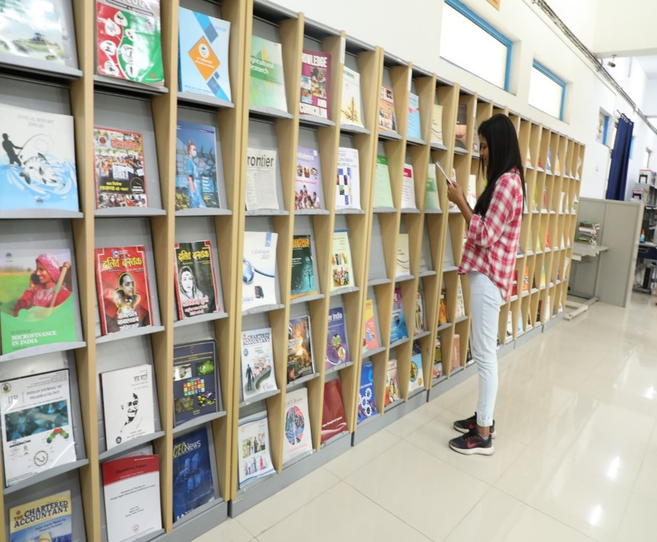

The University Library has been on a rapid and consistent path of expansion and development since its inception in 2009, catering to the learning and research requirements of teachers and students at the university. Carefully designed with elegant modular furniture, the library currently houses over 53,000 books and subscribes to 38 print journals/magazines. Additionally, the University Library is a subscriber to 8,231 full-text online journals through the e-Shodh Sindhu Consortium. Independently, it has access to renowned full-text publishers such as the American Chemical Society, American Physical Society, Annual Reviews, JSTOR, Oxford University Press, Project Muse, Science Direct, Springer Link, and Taylor & Francis, and more.
The University Library provides access to all major databases, including SCOPUS, SciFinder, Web Of Science, Lexis-Nexis, CMIE-ProwessIQ, CMIE-States of India, Indiastat.com, etc. It is fully air-conditioned and strategically located at the Academic Block, offering state-of-the-art seating facilities and a quiet, restoring ambiance. The library's interior is equipped with Wi-Fi connectivity, enabling users to access both offline and online resources while within the premises.
Moreover, the University Library is equipped with Radio Frequency Identification (RFID) and Electromagnetic Security System (EMSS), providing an automated self-issue return facility for users and ensuring high-end security. The Online Public Access Catalog (OPAC) is accessible on the internet at https://opac.cup.edu.in/, offering features for searching, reserving, and online re-issuing.

HOSTEL
STUDENT HOSTEL

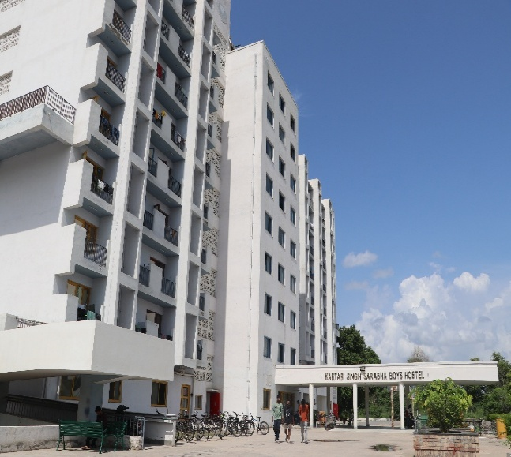
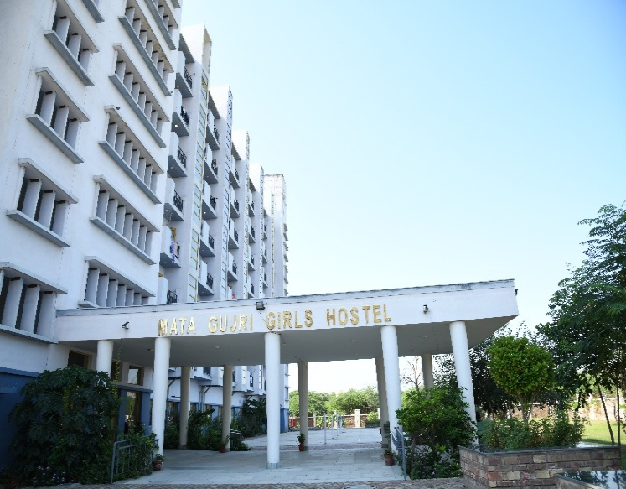

Choosing a University is also about choosing a new home. We ensure that students dwell in a healthy environment that helps them to grow and learn without any obstacle. The University has separate hostels for boys and girls with all modern facilities. The hostel mess serves fresh and hygienic food.

The University has 2 Girls’ hostels and 2 Boys’ hostels. The facilities provided in the hostels are: Wi-Fi, bed, Mattresses, Study Table, Chair, Almirah, 24x7 Water and Electricity supply, Housekeeping facility, Hygienic food, Common Room with TV facility.

Note: Limited hostel facility is available.
HEALTH CARE CENTRE
The University greatly values the health of its students and staff. A Health Centre has been established to facilitate treatment of general ailments, first aid and referral services to the employees and students. Two Medical Officers have been appointed on regular basis at the Health Centre. OPD timings are from 09:00 A.M. to 05:00 P.M. except Sunday & Gazetted Holidays. Medicines given from Health Centre are free of cost and emergency kits are provided at various places for First Aid. The Health Centre also looks after the social, preventive and environmental of the Campus.

Facilities:
  - Minor OPD facility for treatment of general ailments.
  - In-house facility covering basic medicines and pain killers.
  - In-house availability of Ambulance for referrals by Medical Officer in case of dire emergency on Campus on nominal payment no profit no loss policy.
  - In case of dire emergency, on call availability of Medical Officer and Supporting Staff.
  - Health advisories are issued from time to time.

TRANSPORT

University has buses for convenience of the faculty and students. Bicycles and E-ricksaw to commute within campus.
MUSEUM

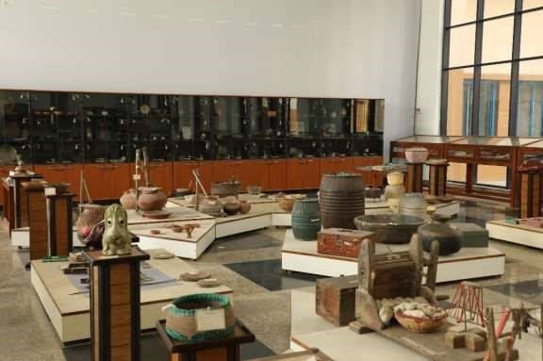

University Museum houses vast collection of archaeological exhibits, including that of Harappan Civilization, excavated from Malwa region of Punjab. Exhibits also include a photo gallery on historical and cultural transformation of Bathinda City.

SPORTS

Besides beautiful walking trails around the Campus, the University has good sports facilities for the students and staff. Badminton and table tennis courts are available to foster sporting skills. Outdoor Volleyball, running track, Football Ground, Cricket Ground and Basketball Courts are available.

FITNESS CENTRE

“A sound mind lies in a sound body”, therefore, a well equipped air-conditioned Fitness Centre-cum Gym is fully functional in the University. Any student can avail benefit of this facility on nominal charges as fixed by the University time to time.

COMMITTEES/CELLS/ASSOCIATIONS

PLACEMENT CELL

The Placement Cell of the University has been established with an aim of facilitating Interactions between the Industries and Students who are in the final year of their Course. The purpose of the Placement Cell is to place students in credible organizations, and help them getting an appropriate job in sync with their intellectual aptitude. To provide excellent facilities for learning combined with a rewarding career is the motto of the Institution. The students are provided with the best research facilities and the lab infrastructure for the execution of their innovative ideas. Helping them to execute it, the dedicated faculty of the University helps them in comprehending the labyrinths of scientific world.
STUDENT COUNSELLING CELL

The students are counselled throughout, during their stay in the University regarding their career options, which in turn prepare and equip the young aspirants to explore the best avenues of opportunities.

- To counsel and guide students on various issues and help them to manage academic and personal demands of a University life effectively.
- To help students of all beliefs and identities who may react to certain events with feelings that include anger, hurt, confusion, fear, helplessness, loneliness, and hopelessness.
- To counsel the students requesting a withdrawal from a specific academic Programme for non-academic reasons.
- To provide prompt counselling for mental health emergencies arising on account of highly charged events at the Campus.
- The Student Counselling Cell shall provide comprehensive preventive and clinical services to students enrolled for various academic Programmes in the University. The goal of the Cell would be to enhance the psychological wellbeing of students so they can take full advantage of the educational opportunities at the University. Some of the presentations that the Counselling Center will offer include academic success skill, conflict resolution, dealing with difficult situations, stress management techniques and time management. All student contacts and information obtained in the course of counselling will be confidential.
GRIEVANCE REDRESSAL CELL

In order to attend to the students' complaints, a Grievance Redressal Cell has been setup in the University. It offers immediate and effective redressal to the problems reported by the students and work towards providing a safe and secure atmosphere for the holisticgrowth of the students. The University has adopted UGC (Redress of Grievances ofStudents) Regulations, 2023. The students may register their grievances as per the notification of the UGC at the appropriate Forum. Central University of Punjab has already notified the committees constituted in compliance of the UGC (Redress of Grievances of Students) Regulations, 2023 vide Ref. No. CUPB/COE/2023/138 Dated 08.05.2023. Link is Given Below: https://cup.samarth.ac.in/index.php/site/login or https://cup.samarth.ac.in/index.php/public_g rievance/grievance-public/public

ANTI-RAGGING CELL

The University has a zero tolerance policy towards ragging-related matters. All issues in this regard will be dealt with utmost urgency and stringent action will be taken against those who are involved. A copy of UGC Regulations on curbing the menace of ragging have been distributed to all students upon admission and have procured undertakings and affidavits from the students as well as parents in this regard. Unabridged version of the UGC Regulations in this regard can be accessible at http://bit.ly/UGC-Ragging.
ANTI-DISCRIMINATION CELL

The University community comprises of heterogeneous population from different parts of Country, different religious/caste affiliations, linguistic heterogeneity and persons with various financial backgrounds. Discriminations based on caste/sex/appearance/state of domicile etc. will be dealt with extreme seriousness.
The University puts very best efforts to ensure that the minority community faces no discriminating incidents in the Campus.
COMPETITIVE EXAMINATION CELL

To prepare the students to face different competitive examinations and help them acquire the requisite knowledge to excel in their studies, the University has a Competitive Examination Cell which conducts coaching classes for exams like UGC/CSIR-NET, ICMR, DBT, GATE, GPAT, Civil services examination, etc. Classes for these competitive examinations are held in the evening, so that the regular class schedule of the University is not disturbed.

Coaching is provided in General Knowledge, Information and Communication Technology (ICT), Reasoning (including Mathematical), Current Affairs, Data interpretation, Research Aptitude, People and environment, Higher Education System: Governance, Polity and Administration for UGC NET Paper-I examinations. For CSIR Net examination coaching is provided in Life Sciences, Environmental Sciences, Chemical Sciences and other subjects. Subject specific classes are conducted on the basis of the demand raised by the students. These classes are also in the form of remedial classes. The faculty members also put efforts to provide guidance for the slow learners. A team of committed teachers and specialists of proven merit provide a professional edge to the Cell. Over the years, the Cell has catered to the need of students with fair degree of success. This has greatly helped to improve the performance of all the students in various examinations. The Cell, in the long run, will start coaching for civil services examinations.

Objectives:

- To provide intensive subject specific coaching for UGC/CSIR-NET, ICMR, DBT, GATE, GPAT etc. and Civil services examination (in future);
- To build positive state of mind and self-confidence among the students;
- To encourage SC/ST/OBC and women candidates to appear in competitive examinations.

DR. AMBEDKAR CENTRE OF EXCELLENCE (DACE)

Dr. Ambedkar Centre of Excellence (DACE) at the Central University of Punjab is established on 1st of April, 2022 by Dr. Ambedkar Foundation, Ministry of Social Justice & Empowerment, Government of India. The ministry has approved this centre to coach Scheduled Castes students for Union Public Service Commission’s Civil Services Examination. The aim of the centre is to empower Scheduled Castes students for competitive exams by providing the best and free coaching facilities in the Central University of Punjab, Bathinda. Dr. Ambedkar Centre of Excellence (DACE) at Central University of Punjab aims to contribute to this national scheme through the optimum use of university infrastructure, academic resources, expertise of diverse faculty, and contribution of different cells from the university, and the advantage of location of the university in the state which has the highest percentage of targeted beneficiaries.
PERSONALITY AND LANGUAGE DEVELOPMENT CELL

Personality and Language Development cell of the university has been established to foster soft- skills and communication skills for the students. The cell regularly organizes activities including soft-skill development workshops, communication skills training and general knowledge quiz competition. Students actively participate in these programs in view of today’s highly competitive and stressful academic/career environment. As a part of the activities of this Cell, a Communication Skills and Personality Development training course in English is being conducted three times a week at the Language Lab. The objective of this course is to help students to effectively handle real life communication- specific challenges and to help them grow as leaders. This course aims to enable students to learn techniques of Effective Communication, Personal Interview, Group Discussion, Personality Development and Leadership Skills.
SC/ST/OBC AND MINORITIES CELL

SC/ST/OBC and Minorities Cell is committed to provide an environment that promotes diversity and respects everyone regardless of color, religious belief or culture. While maintaining diversity of all kinds, it also commits to ensuring protection of everyone including minorities and acting as per the provisions of Constitution of India.
CULTURAL COMMITTEE

The Cultural Committee in the University makes one forget about life’s woes and transports one and all into a world of beats and rhythms. Students are given proper training through experts in dancing, singing, acting, etc. The students perform plays on serious issues like female foeticide, dowry, environment pollution etc. which brings tears to everyone eyes and remind each one present of their duty towards the wrong prevalent in the country. Various events like drama, dance (group and individual performances), skit, musical performances (group and solo), poetry recitation competition, music competition, dance competitions, traditional dress competitions etc. are organized.

ALUMNI ASSOCIATION

The Alumni Association of Central University of Punjab (AACUP) aspires to foster an increased interaction amongst the Alumni. A series of activities will be organized once the Association becomes active. A glimpse of what we as facilitators intend to do are:

- To set up a link with the Alumni of all the Centres/Departments and enroll them as members.
- To encourage the Alumni to take an active and continued interest in the activities and progress of the University.
- To honour those distinguished alumni members, who bring laurels to themselves as well as the University in their respective domains.
- To arrange get-together of the Alumni on a regular basis.

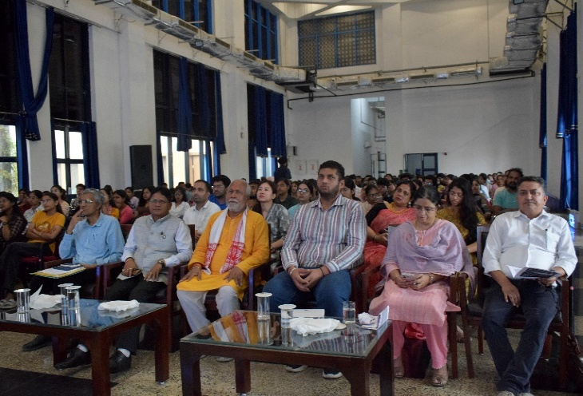
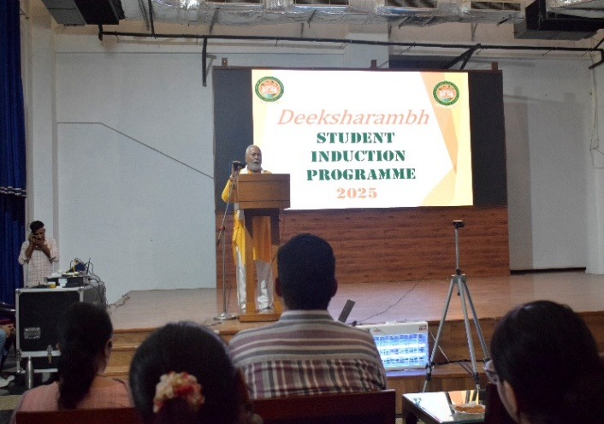
SALIENT FEATURES OF THE UNIVERSITY
DEEKSHARAMBH: STUDENT ORIENTATION

The orientation program is meant to orient the students to the Campus life. The program facilitates the successful academic and personal transition of new students to the University community.

Features
- It gives an overview of University's culture, resources and services along with rules and regulations.
- It is held at the beginning of the Session.

Objectives
- To welcome the student to the University and engage them with the legacy, traditions and values of our University.
- To introduce students to the rigorous academic life of the University and opportunities, responsibilities and facilities available.
- To explain rules and regulations of the University especially related to teaching learning and examination.
STUDENT CODE OF CONDUCT

The University recognizes and values the diversity of students and their expectations. The University is committed to treating students in a fair and transparent manner. The code of conduct is formulated to provide a clear statement of the University’s expectations of studen ts in respect of academic matters and personal behavior.

  - The student must submit their assignments, Lab. files, seminar reports etc. given by the teachers in time.
  - No student must abstain from classes without prior permission.
  - Students are expected to speak politely and use courteous language when communicating with University officials, staff members and other students.
  - Since all the students to be admitted in the University have attained the age of majority, it is expected that they understand their responsibilities. They are the best judge of their interests. The students residing in the hostel will be staying in the hostel at their own risk, liability and consequences.
  - Any student participating in sports/training/cultural or any other activity shall take proper care, reasonable intelligence and precautionary measures to avoid any injury. Where any physical injury is caused due to recklessness, violation of rule, laws in existence, safety norms as advised or instructed to undertake such activities, the responsibility shall be exclusively borne by the student. The University shall bear no responsibility for damage caused by the voluntarily acceptance of the risk associated therein. It shall be responsibility of the student to take care in order to avoid injuries. So far as sports are concerned, the purpose of the University is only to facilitate the recreational and rejuvenation opportunities to the students in view of their rigorous academic calendar. Henceforth, the University shall not be liable to any damages, financial or other legal liability for injury sustained by the students in these voluntary activities. The students are advised to buy insurance policy or avail the benefit of PMJDY (Pradhan Mantri Jan Dhan Yojna) to meet out any exigency or unforeseen mishap.
  - Students must maintain decorum in the University bus.
  - It is the students’ and his guardian’s responsibility to update any changes in their parents / guardians and their own address and contact number within a week. Failure to update may invoke disciplinary action against the student.
  - Wearing a helmet for two wheeler riders is a statutory requirement.
  - Use all University resources including information technology in a lawful and ethical manner for academic purposes only.
  - The students are expected to bear a good moral character.
FEEDBACK SYSTEM

Teaching and learning is a continuous process in which teacher and student develops a bond. Teachers keep getting new students year after year and with the passage of time gain rich experience. In order to improve her/his competence in teaching and/ or research she/he needs the feedback from the students. The students can provide their feedback at the end of every Semester for each Course by hiding their identity. The feedback form is to be filled online, the data of which is kept confidential and is used only for improvement purposes.

RULES & REGULATIONS FOR STUDENTS

- All students are expected to abide by the rules and regulations of the University. Breach of any rule or any other misconduct shall render the student liable for disciplinary action, including expulsion from the University.
- Attendance requirements: All students must attend their classes regularly. The minimum requirement of attendance is 75% of the scheduled lectures.
- Use of Mobile phones: Students possessing mobile phones must keep them switched off when in Class/Labs. Carrying a mobile phone even in switched off mode during examinations is strictly prohibited and shall amount to use of unfair means.
- Ragging: Ragging of any student in any form inside or outside the Campus is punishable offence as per guidelines of Honorable Supreme Court of India with minimum punishment of expulsion from the University. Students and their parents shall be required to submit the undertaking as per Annexure I & II attached with this prospectus.
- Misbehavior: Students found misbehaving with other students or staff member will face disciplinary action.
- Infrastructure Damage: Students must take care of their Campus. Any student found damaging the University infrastructure will be fined to recover the losses.
- Ignorance of the rules and regulations of the University will not be entertained as an excuse.

BEHAVIOUR AND DISCIPLINE
RULES AND REGULATIONS FOR BOYS’ AND GIRLS’ HOSTEL
- A hostel complex should be a place where students can have the best possible conditions for adequate rest and study. Accordingly, due consideration must be accorded to the interests and privacy of other hostellers at all times.

  - The students are expected to display acceptable form of behavior, modesty in dress sense in the common dining area representing an institute of national importance, maintain discipline and decorum in the Campus. Being a student of Central Government Institution, the students must present an example of discipline and self-restraint in their conduct.

  - The University equally respects the rights of all and promotes healthy interaction provided no physical affection between the opposite genders is shown at public places which may invoke legal action in case any complaint is filed. Where the students have any grievance, it should be resolved in a peaceful, dignified and amicable manner through the redressal mechanism of the University. In case of any unacceptable behavior by the room-mate, the other room-mate(s) must report it to the Warden/University authorities through Hostel Representatives.

  - The students should not involve themselves or participate in any strike, dharna or protests etc. Any violation of this rule may make them liable under Punjab Prevention of Damage to Public and Private Properties Act, 2014.

  - Possession, distribution and consumption of alcohol beverages, prohibited drugs, and chewable tobacco in the hostel complex is strictly prohibited. Recover of residues of Cigarettes, Tobacco, Alcohol Beverages or any prohibited item shall be punishable with a fine of Rs. 500/- only at the 1st instance. In case of 2nd time, penalty shall be Rs. 1,000/- only. In case of continuance of violation of this rule, the students shall be expelled from the Hostel.

  - All fans, lights and electric appliances must be switched off when not in use. In case, a fan/ light or any other electric appliances in room is in use in the absence of student or locked room, the 1st time Penalty shall be Rs. 500/- only and in case of 2nd time, penalty shall be Rs. 1,000/- only. In case of continuance of violation of this rule, the students shall be expelled from the Hostel.

  - Late night Birthday Parties, Social or Political gatherings or Processions in the hostel complex or within the campus premises are not permitted without the prior written permission of the hostel warden and / or University authorities. Such parties shall be organized only between 8.00 p.m. - 9.30 p.m. with the permission of the appropriate authority. In case of violation or any complaint of physical discomfort or intrusion upon the privacy of other residents in peace hours (9.30 p.m. to 6.00 a.m.) is received, it will be the collective responsibility of the hostel residents involved in any such endeavor and will be proceeded accordingly for disciplinary action.

  - Ragging is a serious offence. The University adopts Zero Tolerance towards Ragging. Hostellers found guilty of committing such an offence can be evicted from the hostel and shall be liable to legal proceedings as per the directives of Supreme Court/MoE/UGC.

  - The students must return to the hostel by 10:00 p.m. every day and are not allowed to leave the hostel before 6:00 a.m.

  - The students will be allowed to stay out of the hostel on submission of proper application duly authorized by the parent on a call received from the designated numbers of parents and only if the permission granted in writing by the hostel warden. Any falsification or impersonation may invoke disciplinary as well as legal proceedings against the guilty.

  - The occupant(s) of a room is/are responsible for any damage to the property in the room during his/her occupancy. In case of damage to or loss of hostel property, the cost + fine equivalent to the amount of cost will be recovered from the student(s) responsible for such damage or loss.

  - The notice Boards of the University shall not be used by the student without written permission of the DSW in case of Academic Block, Dean/HoD in case of Class room and Warden/s in case of Hostels.

  - Competent Authority reserves the right to revise Hostel rules from time to time.
UPKEEP OF THE HOSTEL

- The student(s) shall not move any furniture from its proper allotted place (room/common room) and not damage in anyway. No dues to the students shall be given only after verification of the upkeep of room and accessories provided. In case, any of the items issued to the occupant of the room is missing during the occupancy, the occupant shall be responsible for its loss or damage and pay the cost + fine equivalent to the amount of cost.
  - Pasting of posters, writings, wall chalking, slogans of any kind or defacing the hostels or walls of Hostels in any form is not allowed. The resident of the room shall be responsible for upkeep of the room. Where any painting is drawn on the walls or doors of the hostel or any defacing is made by anyone, it will be removed or repainted at the cost of occupant and allotted of the room.
  - The students will be responsible for keeping their rooms’ clean and tidy at all times.
  - Cooking, making tea etc. is not allowed in the hostel. Any extension of plugs or wires is prohibited.
  - Hostel staff, Electricians, plumbers, security and any other service person may enter rooms as and when necessary in the course of their duty under the directive of hostel warden. However, every effort will be made to respect the privacy and dignity of the hostellers.
  - The University Authority reserves the right to make spot checks on the hostel and rooms without having to give prior notice to the students.
  - The University Authority reserves the right to move hostellers to other hostel units or any other alternative place if there is a necessity.

VISITORS
  - Visitors including parents are allowed only into the visitor’s area of the hostel during the visiting hours as follows: -
  - Weekdays (Monday to Friday): 5:00 p.m. to 8:00 p.m. & 7:30 a.m. to 8:30 a.m.
  - Weekend (Saturday & Sunday) and Holidays: 7:30 a.m. to 8:00 p.m.
  - All visitors must register at the Security Section and provide all details and documents as asked before entering the hostel complex. All visitors must leave the hostel complex by 8:00 p.m.
  - Students are not permitted to allow visitors of the opposite sex into rooms at any time for whatever reason. Any hostellers found violating this rules will be evicted from the hostel.
  - Any unauthorized entry in campus premises or hostels shall amount to criminal trespass and will be dealt with according to law in existence.
  - Non-Hostel students are prohibited in the hostel without the permission of hostel warden. The student who violates this is answerable to the Warden.

SECURITY
  - The University Authority is not responsible for any loss of private property. Hostellers are strongly advised to lock all your valuable items such as Mobile phones, Laptop, Watches, Money etc. at all times.
  - Hostellers are not permitted to change rooms or sleep anywhere other in their own room.
  - Any student, who finds anything unusual about his room-mate or finds his missing for more than 24 hours, must report to the hostel Warden immediately. This is to enable the University authorities to take immediate action if any untoward incident takes place.
  - Possession, distribution and use of fire-arms, lethal weapons including air gun, contraband drugs, alcohol, toxic and hazardous material are strictly prohibited in the hostel. Keeping electric appliances such as T.V., VCR, heater, iron, oven etc. in the rooms is also prohibited.
  - Pets are not allowed in the hostel complex.
REVISION OF RULES AND REGULATIONS
The University reserves the right to revise or update the rules and regulations from time to time and will keep the hostellers informed of any changes in the form of notices on the hostel notice boards. Ignorance of rules will not be accepted as an excuse.

IMPORTANT CONTACT NUMBERS AND EMAIL IDs
All Important contact number and Email id’s of University Faculty and Employees are available on the University website.

Office | Contact No. | Email address
Dean In-charge Academics | 0164-2864-151 | dia@cup.edu.in, daaoffice@cup.edu.in
Registrar’s Office | 0164-2864-206 | registraroffice@cup.edu.in
Controller of Examinations' Office | 0164-2864-175 | coe@cup.edu.in, controlleroffice@cup.edu.in
Admissions | 0164-2864-179 | admissionscup@cup.edu.in
Establishment Branch | 0164-2864-171 | establishment@cup.edu.in
Academics Branch | 0164-2864-180 | academic.section@cup.edu.in
Dean Students Welfare | 0164-2864-152 | dsw@cup.edu.in
Public Information Officer | 0164-2864-203 | robin.jindal@cup.edu.in
Finance Branch | 0164-2864-194 | fo@cup.edu.in
Computer Centre | 0164-2864-297 | sa@cup.edu.in
Library | 0164-2864-284 | library@cup.edu.in

LIST OF DOCUMENTS REQUIRED FOR ADMISSION

S. No. | List of Documents | Self-Attested  Photocopy | Original
1. | Secondary School (Class 10th) Marks Sheet Or Valid Date of Birth Certificate | Self-Attested Photocopy
2. | Post-Graduation Marks Sheet or Grade Sheet (As applicable) – First Year | Self-Attested Photocopy
3. | Post-Graduation Marks Sheet or Grade Sheet (As applicable) – Second Year | Self-Attested Photocopy
4. | Post-Graduation Degree | Self-Attested Photocopy
5. | Medical Fitness Certificate |  | Original
6. | Declaration related to health | - | Original
7. | Anti-Ragging Form duly signed by the Student & Parents | - | Original
8. | Certificate of Conduct from Head of Institution/ Character Certificate | - | Original
9. | Migration Certificate - Original* | - | Original
10. | Category certificate as per GOI rules (Latest certificate for OBC candidates - NON CREAMY LAYER etc.) | Self-Attested Photocopy
11. | Undertaking for gap year, if applicable. | - | Original
12. | “NET- JRF” or any other national level test (with existing validity) recognized by UGC, if applicable. | Self-Attested Photocopy
13. | NOC from Employer (In case of Part-time Ph.D. only) | - | Original
14. | Any other document if needed (……………………………………..) | - | Original
15. | Two recent passport size photographs | - | Original
Original documents marked will be retained permanent by the University.

Note: Candidate has to bring all original documents for verification along with one set of self-attested photocopy.

OBC CERTIFICATE FORM AT

FORM OF CERTIFICATE TO BE PRODUCED BY OTHER BACKWARD CLASSES APPLYING FOR APPOINTMENT TO POSTS / ADMISSION TO CENTRAL EDUCATIONAL INSTITUTES (CEIs), UNDER THE GOVERNMENT OF INDIA

“This certificate MUST have been issued with last six months”
This is to certify that Shri/Smt./Kum. Son/Daughter of Shri/Smt. of Village/Town District/Division in the State belongs to the Community which is recognized as a backward class under:
(i) Resolution No. 12011/68/93-BCC(C) dated 10/09/93 published in the Gazette of India Extraordinary Part I Section I No. 186 dated 13/09/93.
- Resolution No. 12011/9/94-BCC dated 19/10/94 published in the Gazette of India Extraordinary Part I Section I No. 163 dated 20/10/94.
- Resolution No. 12011/7/95-BCC dated 24/05/95 published in the Gazette of India Extraordinary Part I Section I No. 88 dated 25/05/95.
3) Resolution No. 12011/96/94-BCC dated 9/03/96.
4) Resolution No. 12011/44/96-BCC dated 6/12/96 published in the Gazette of India Extraordinary Part I Section I No. 210 dated 11/12/96.
5) Resolution No. 12011/13/97-BCC dated 03/12/97. 6) Resolution No. 12011/99/94-BCC dated 11/12/97. 7) Resolution No. 12011/68/98-BCC dated 27/10/99.
- Resolution No. 12011/88/98-BCC dated 6/12/99 published in the Gazette of India Extraordinary Part I Section I No. 270 dated 06/12/99.
- Resolution No. 12011/36/99-BCC dated 04/04/2000 published in the Gazette of India Extraordinary Part I Section I No. 71 dated 04/04/2000.
(xi) Resolution No. 12011/44/99-BCC dated 21/09/2000 published in the Gazette of India Extraordinary Part I Section I No. 210 dated 21/09/2000.
a) Resolution No. 12016/9/2000-BCC dated 06/09/2001.
b) Resolution No. 12011/1/2001-BCC dated 19/06/2003.
c) Resolution No. 12011/4/2002-BCC dated 13/01/2004.
d) Resolution No. 12011/9/2004-BCC dated 16/01/2006 published in the Gazette of India Extraordinary Part I Section I No. 210 dated 16/01/2006.
Shri/Smt./Kum. and/or his family ordinarily reside(s) in the District/Division of State. This is also to certify that he/she does not belong to the persons/sections (Creamy Layer) mentioned in Column 3 of the Schedule to the Government of India, Department of Personnel & Training O.M. No. 36012/22/93-Estt.(SCT) dated 08/09/93 which is modified vide OM No. 36033/3/2004 Estt.(Res.) dated 09/03/2004.

Dated:
District Magistrate/ Deputy Commissioner, etc.
Seal
NOTE:
- The term ‘Ordinarily’ used here will have the same meaning as in Section 20 of the Representation of the People Act, 1950.
- The authorities competent to issue Caste Certificates are indicated below:
  - District Magistrate / Additional Magistrate / Collector / Deputy Commissioner / Additional Deputy Commissioner / Deputy Collector / First Class Stipendiary Magistrate / Sub-Divisional magistrate / Taluka Magistrate / Executive Magistrate / Extra Assistant Commissioner (not below the rank of Ist Class Stipendiary Magistrate).
  - Chief Presidency Magistrate / Additional Chief Presidency Magistrate / Presidency Magistrate.
  - Revenue Officer not below the rank of Tehsildar and
  - Sub-Divisional Officer of the area where the candidate and / or his family resides.

SC/ST CERTIFICATE FORMAT

FORM OF CERTIFICATE TO BE PRODUCED BY A CANDIDATE BELONGING TO SCHEDULED CASTE OR SCHEDULED TRIBE
This is to certify that Shri/Smt./Kum. Son/Daughter of Shri
Of village/Town in District/ Division
of the State/Union Territory belongs to the
caste/ Tribe, which is recognized as a Schedule Caste/Scheduled Tribe under.

The Constitution (Scheduled Castes) order, 1950. The Constitution (Scheduled Tribes) order, 1950.
The Constitution (Scheduled Castes) (Union Territory) order, 1951. The Constitution (Scheduled Tribes) (Union Territory) order, 1951.
(As amended by the Scheduled Castes and Scheduled Tribes (Modification) Order 1956, the Bombay Reorganization Act, 1960, the Punjab Reorganization Act, 1966, The State of Himachal Pradesh Act, 1970, the North Eastern Areas (Reorganization Act, 1971) and the Scheduled Castes and Scheduled Tribes orders (Amendment) Act, 1976.)
*The constitution (Jammu & Kashmir) Scheduled Caste Order, 1956;
*The Constitution (Andaman and Nicobar Islands) Scheduled Tribes, 1959, as amended by the Scheduled Castes and Scheduled Tribes orders (Amendment) Act. 1976;
*The Constitution (Dadra and Nagar Haveli) Scheduled Castes Order 1962; *The Constitution (Dadra & Nagar Haveli) Scheduled Tribes Order, 1962; *The Constitution (Pondichery) Scheduled Castes Order, 1964;
*The Constitution (Uttar Pradesh) Scheduled Tribes Order, 1967;
*The Constitution (Goa, Daman &Dieu) Scheduled Castes Order, 1968;
*The Constitution (Goa, Daman &Dieu) Scheduled Tribes Order, 1968; *The Constitution (Nagaland) Scheduled Tribes Order, 1970;
*The Constitution (Sikkim) Scheduled Castes Order, 1978;
*The Constitution (Sikkim) Scheduled Tribes Order, 1978;
*The Constitution (Scheduled Castes) Orders (Amendment) Act, 1990.
*The Constitution (Scheduled Tribes) Order, (Amendment) Ordinance, 1991.
*The Constitution (Scheduled Tribes) Order, (Second Amendment) Act, 1991. *The Constitution (Scheduled Tribes) Ordinance, 1996
This certificate is issued on the basis of the Scheduled Castes/Scheduled Tribes Certificate issue to
Shri Father of Shri of village/town in District/Division of the State/UT who belongs to the caste/Tribe which is recognized as a SC/ST in the State/Union Territory issued by the (name of the prescribed issuing authority) vide their No. Dated or Shri and or his/her family ordinarily reside(s) in Village/Town of District/Division of the State/Union Territory of .

Place | Signature
Date | Designation
 | (With seal of Office)
NOTE: - The terms ordinarily reside(s) used here will have the same meaning as in Section 20 of the Representation of the People Act, 1950.
SC Certificate issued from Maharashtra State must be validated by Social Welfare Department and ST Caste certificate must be validated by Tribal Development Department of Maharashtra Government
LIST OF AUTHORITIES EMPOWERED TO ISSUE CASTE/TRIBE CERTIFICATE:
- District Magistrate/Additional District Magistrate/Collector/Deputy Commissioner /Additional Deputy Commissioner/Dy. Collector/ 1st Class Stipendiary Magistrate/Sub Divisional Magistrate/Extra Assistant Commissioner/Taluka Magistrate/Executive Magistrate.
- Chief Presidency Magistrate/Additional Chief Presidency Magistrate/Presidency Magistrate.
- Revenue Officers not below the rank of Tahsildar.
- Sub-Divisional Officers of the area where the candidate and/or his family normally resides.

PWD CERTIFICATE FORM

Format for Physically Challenged (PH)/Persons with Disabilities (PWD) Certificate (To be obtained by the candidate)
(To be filled by Medical Board notified under PWD Act)

Certificate No:

Affix here recent Photograph showing the disability duly attested by Medical Superintendent
/CMO/Head of Hospital (with seal

Date:

This is to certify that Mr./Ms son /
daughter of Mr./Mrs. Age
male/female, Registration No. is a case of
. He/She is physically disabled/visual disabled/speech and hearing disabled/having mental retardation/leprosy cured and has %( per cent) permanent (physical impairment/visual impairment/speech and hearing impairment etc.) in relation to his/her

. Note:

This condition is progressive/not progressive/likely to improve/not likely to improve*.

1. Re-assessment is not recommended/ is recommended after a period of months / years*. (*Strike out whichever is not applicable)

Signature of Dr. | Signature of Dr. | Signature of Dr.
Name of Dr. | Name of Dr. | Name of Dr.
Specialization | Specialization | Specialization
Seal with Degree | Seal with Degree | Seal with Degree
(Member, Medical Board) | (Member, Medical Board) | (Member, Medical Board)

Signature/Thumb impression of Patient

Countersigned by the Medical Superintendent/CMO/Head of Hospital (with seal)

EWSs CERTIFICATE FORMAT

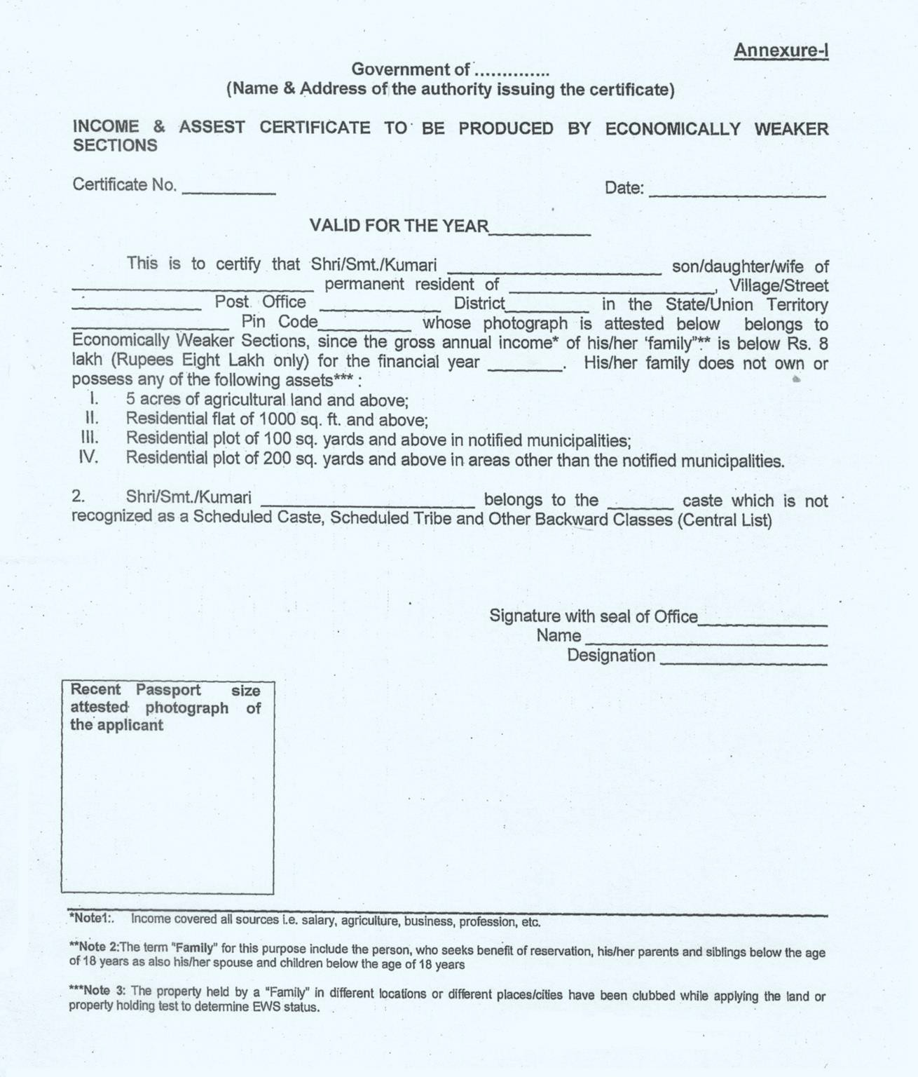
ANNEXURE I
UNDERTAKING BY THE STUDENT

I, (full name of student with Institute Roll Number) s/o/ d/o Mr./Mrs./Ms. , having been admitted to (name of the institution) , have received or downloaded a copy of the UGC Regulations on Curbing the Menace of Ragging in Higher Educational Institutions, 2009, (hereinafter called the “Regulations”) carefully read and fully understood the provisions contained in the said Regulations.

- I have, in particular, perused clause 3 of the Regulations and am aware as to what constitutes ragging.

- I have also, in particular, perused clause 7 and clause 9.1 of the Regulations and am fully aware of the penal and administrative action that is liable to be taken against me in case I am found guilty of or abetting ragging, actively or passively, or being part of a conspiracy to promote ragging.

- I hereby solemnly aver and undertake that

  - I will not indulge in any behaviour or act that may be constituted as ragging under clause 3 of the Regulations.

  - I will not participate in or abet or propagate through any act of commission or omission that may be constituted as ragging under clause 3 of the Regulations.

- I hereby affirm that, if found guilty of ragging, I am liable for punishment according to clause 9.1 of the Regulations, without prejudice to any other criminal action that may be taken against me under any penal law or any law for the time being in force.

- I hereby declare that I have not been expelled or debarred from admission in any institution in the country on account of being found guilty of, abetting or being part of a conspiracy to promote, ragging; and further affirm that, in case the declaration is found to be untrue, I am aware that my admission is liable to be cancelled.

- Along with the above mentioned points I do hereby declare that

- I will obey the code of conduct of the institute and do not indulge in any kind of in-disciplined activity while in and off the institution campus.

- I will be solely responsible for any kind of accident/mishap caused on account of the above mentioned clause (6.a).

Undertake this day of month of year.

Signature of Student ___________________________

Name: ________________________________

ANNEXURE II

UNDERTAKING BY PARENT/GUARDIAN

I, Mr./Mrs./Ms. (full name of parent/guardian) father/mother/guardian of , (full name of student with University Roll Number) , having been admitted to (name of the institution) , have received or downloaded a copy of the UGC Regulations on Curbing the Menace of Ragging in Higher Educational Institutions, 2009, (hereinafter called the “Regulations”), carefully read and fully understood the provisions contained in the said Regulations.
- I have, in particular, perused clause 3 of the Regulations and am aware as to what constitutes ragging.

- I have also, in particular, perused clause 7 and clause 9.1 of the Regulations and am fully aware of the penal and administrative action that is liable to be taken against my ward in case he/she is found guilty of or abetting ragging, actively or passively, or being part of a conspiracy to promote ragging.

- I hereby solemnly aver and undertake that

- My ward will not indulge in any behaviour or act that may be constituted as ragging under clause 3 of the Regulations.

- My ward will not participate in or abet or propagate through any act of commission or omission that may be constituted as ragging under clause 3 of the Regulations.

- I hereby affirm that, if found guilty of ragging, my ward is liable for punishment according to clause 9.1 of the Regulations, without prejudice to any other criminal action that may be taken against my ward under any penal law or any law for the time being in force.

- I hereby declare that my ward has not been expelled or debarred from admission in any institution in the country on account of being found guilty of, abetting or being part of a conspiracy to promote, ragging; and further affirm that, in case the declaration is found to be untrue, the admission of my ward is liable to be cancelled.

- Along with the above mentioned points I do hereby declare that

  - My ward will obey the code of conduct of the institute and do not indulge in any kind of in-disciplined activity while in and off the institution campus.

  - My ward will be solely responsible for any kind of accident/mishap caused on account of the above mentioned clause (6.a).

Declared this day of month of year.

Signature of Parent/Guardian
Name:
Address:
Telephone/ Mobile No.:

For Admission Enquiry, please contact Admission Cell at 09464269330
(Monday to Friday 09.00 am to 05:00 pm)

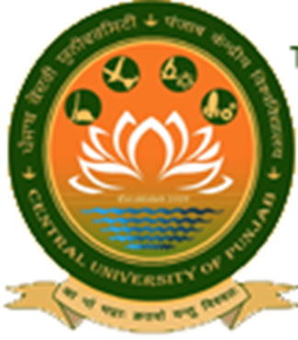

Central University of Punjab

(Established under Central Universities Act, 2009)
VPO: Ghudda, Distt: Bathinda – 151 401 (Punjab), India Website: www.cup.edu.in
Email: admissions@cup.edu.in

FACULTY PROFILE available on Department website.

